TITLE OF THE PAPER

Author Name
Author affiliation with full address

Abstract

Abstract should be limited to 100 words and convey the main points of the paper and significance of the results. The title should be brief, specific and amenable to indexing. Not more than five keywords should be indicated separately; these should be chosen carefully and must not be phrases of several words.

Keywords: Guidelines, IGS, Journal, Template, Manuscript

Introduction
The article should be submitted in duplicate (the original typescript and a copy) typed in double-spaced (Normal, plain font like 10-point Times New Roman) of one side of A4 paper with a left hand margin of 4 cm and should not exceed 5,000 words.

The pages should be numbered consecutively, starting with the title page and through the text, reference list, tables and figures. The manuscript should be ordered as follows: Title page, abstract, key words, text, acknowledgements, references, tables, figures (on separate page preceding the first figure), figures (one figure per page; the figures should be labelled).

References should be listed in alphabetical order, serially numbered at the end of the paper as per MLA format. The list of references should only include works that are cited in the text and that have been published or accepted for publication

Methodology
The title should be brief, specific and amenable to indexing. Not more than five keywords should be indicated separately; these should be chosen carefully and must not be phrases of several words. Abstract and summary should be limited to 100 words and convey the main points of the paper, outline the results and conclusions, and explain the significance of the results.

Results and Discussion
Maps and charts should be submitted in the final or near-final form. The authors should however agree to revise the maps and charts for reproduction after the article is accepted for publication. Each figure should have a concise caption describing accurately what the figure depicts.

If you include figures that have already been published elsewhere, you must obtain permission from the copyright owner(s) for both the print and online format. Please be aware that some publishers do not grant electronic rights for free and that IGS will not be able to refund any costs that may have occurred to receive these permissions.

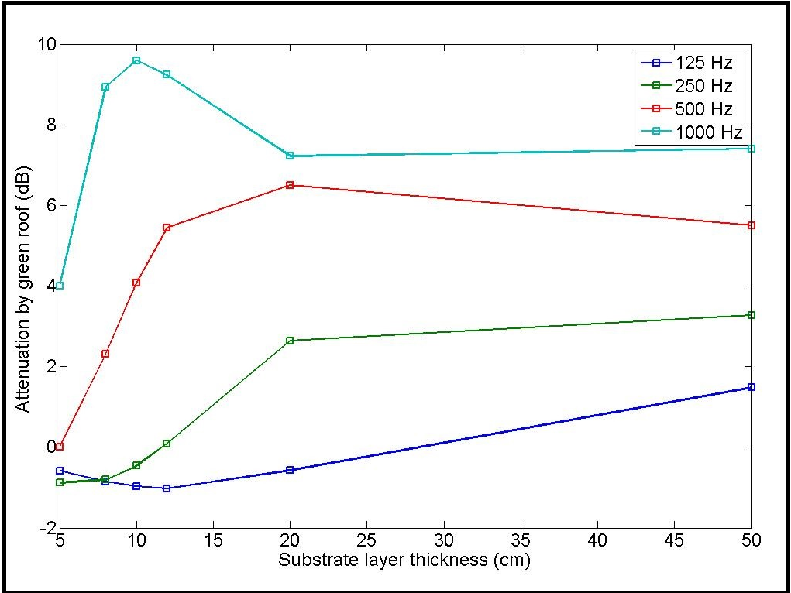
Figure 1: Attenuation of Noise by green roof
Source - http://www.acoustics.org/press/155th/renterghem.html
Table 1. A Comparison of …..
Coloumn 1 | Coloumn 2 | Coloumn 3
Source: xxxxxx

Conclusion
The title should be brief, specific and amenable to indexing. Not more than five keywords should be indicated separately; these should be chosen carefully and must not be phrases of several words. Abstract and summary should be limited to 100 words and convey the main points of the paper, outline the results and conclusions, and explain the significance of the results.
Acknowledgement
Acknowledgements of people, grants, funds etc. should be placed in a separate section before the reference list. The names of funding organizations should be written in full.

References

- Haridas, V. K., Chandrasekaran, V. A., Kumaraswamy, K., Rajendran, S., & Unnikrishnan, K. (1994). Geomorphological and Lineament Studies of Kanjamalai Using IRS-IA Data with Special Reference to Groundwater Potentiality. Trans. Instt. Indian Geographers, 16(1), 35-41.
- Strahler, A. H., & Strahler, A. N. (2005). Physical Geography: Science and Systems of the Human Environment John Wiley & Sons, Inc. Hoboken, N.J.
- Brown, S., Hall, M., Andrasko, K., Ruiz, F., Marzoli, W., Guerrero, G. & Cornell, J. (2007). Baselines for Landuse Change in the Tropics: Application to Avoided Deforestation Projects. Mitigation and Adaptation Strategies for Global Change, 12(6), 1001-1026.
- Dasgupta, A. (2013). Big data: The Future is in Analytics. Geospatial World. http://www.geospatialworld.net/Paper/Cover-Stories/ArticleView.aspx?aid=30512. (Accessed on 02 October 2019)
- Green, T. (2009). We Need Publishing Standards for Datasets and Data Tables. Research Information. doi:10.1787/603233448430. (Accessed on 02 October 2013)
- Rutharvel Murthy, K. (2012). Assessment of Groundwater Vulnerability to Contamination using Geospatial Technology and Regional Scale Models in Vellore District, Tamil Nadu, India. Unpublished Ph.D.Thesis, Bharathidasan University, Tiruchirappalli.

